**1.6 REPRESENTATION OF SINUSOIDAL WAVEFORMS**

Many a time, alternating voltages and currents are represented by a sinusoidal wave, or simply a sinusoid. It is a very common type of alternating current (ac) and alternating voltage. The sinusoidal wave is generally referred to as a sine wave. Basically an alternating voltage (current) waveform is defined as the voltage (current) that fluctuates with time periodically, with change in polarity and direction. In general, the sine wave is more useful than other waveforms, like pulse, sawtooth, square, etc. There are a number of reasons for this. One of the reasons is that if we take any second order system, the response of this system is a sinusoid. Secondly, any periodic waveform can be written in terms of sinusoidal function according to Fourier theorem. Another reason is that its derivatives and integrals are also sinusoids. A sinusoidal function is easy to analyse. Lastly, the sinusoidal function is easy to generate, and it is more useful in the power industry. The shape of a sinusoidal waveform is shown in Fig. a.

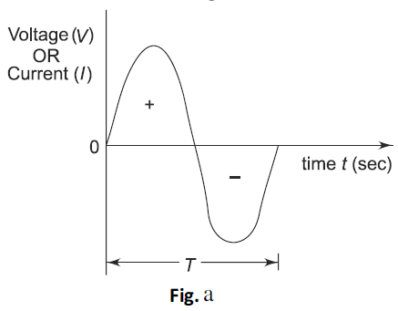

The waveform may be either a current waveform, or a voltage waveform. As seen from the Fig. a, the wave changes its magnitude and direction with time. If we start at time t = 0, the wave goes to a maximum value and returns to zero, and then decreases to a negative maximum value before returning to zero. The sine wave changes with time in an orderly manner. During the positive portion of voltage, the current flows in one direction; and during the negative portion of voltage, the current flows in the opposite direction.

The complete positive and negative portion of the wave is one cycle of the sine wave. Time is designated by t. The time taken for any wave to complete one full cycle is called the period (T ). In general, any periodic wave constitutes a number of such cycles. For example, one cycle of a sine wave repeats a number of times as shown in Fig. b. Mathematically it can be represented as f(t) = f (t + T ) for any t.

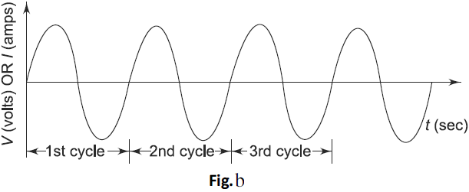

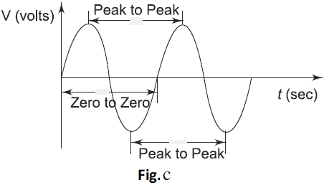

The period can be measured in the following different ways (See Fig. c).

1. From zero crossing of one cycle to zero crossing of the next cycle.
2. From positive peak of one cycle to positive peak of the next cycle, and
3. From negative peak of one cycle to negative peak of the next cycle.

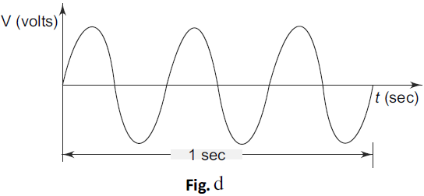

The frequency of a wave is defined as the number of cycles that a wave completes in one second. In Fig. d the sine wave completes three cycles in one second. Frequency is measured in hertz. One hertz is equivalent to one cycle per second, 60 hertz is 60 cycles per second and so on. In Fig. d, the frequency denoted by f is 3 Hz, that is three cycles per second. The relation between time period and frequency is given by

$$f=\frac{1}{T}$$

A sine wave with a longer period consists of fewer cycles than one with a shorter period.

**1.6.1 Angular Relation of a Sinusoidal Wave**

A sine wave can be measured along the X-axis on a time base which is frequency- dependent. A sine wave can also be expressed in terms of an angular measurement. This angular measurement is expressed in degrees or radians. A radian is defined as the angular distance measured along the circumference of a circle which is equal to the radius of the circle. One radian is equal to 57.3°. In a 360° revolution, there are 2π radians. The angular measurement of a sine wave is based on 360° or 2π radians for a complete cycle as shown in Figs (a) and (b).

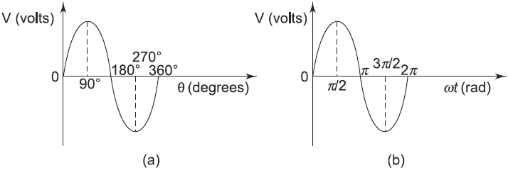

A sine wave completes a half cycle in 180° or p radians; a quarter cycle in 90° or p π/2 radians, and so on.

**1.6.2 Phase of a Sinusoidal Wave**

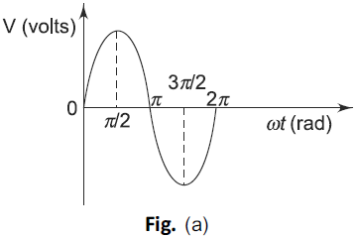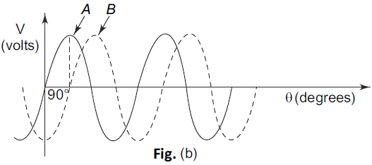

The phase of a sine wave is an angular measurement that specifies the position of the sine wave relative to a reference. The wave shown in Fig. a is taken as the reference wave.

When the sine wave is shifted left or right with reference to the wave shown in Fig. a, there occurs a phase shift. Figures b & c shows the phase shifts of a sine wave. In Fig. b, the sine wave is shifted to the right by 90° (π/2 rad) shown by the dotted lines. There is a phase angle of 90° between A and B. Here the waveform B is lagging behind waveform A by 90°. In other words, the sine wave A is leading the waveform B by 90°. In Fig. c the sine wave A is lagging behind the waveform B by 90°. In both cases, the phase difference is 90°.

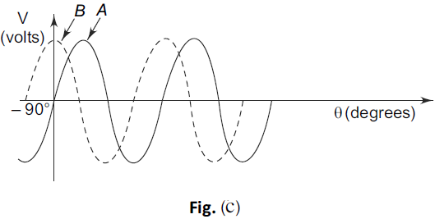

**1.6.3 The Sinusoidal Wave Equation**

A sine wave is graphically represented as shown in Fig. 2.12(a). The amplitude of a sine wave is represented on vertical axis. The angular measurement (in degrees or radians) is represented on horizontal axis. Amplitude A is the maximum value of the voltage or current on the Y-axis.

In general, the sine wave is represented by the equation

v(t) = Vm sin ωt

The above equation states that any point on the sine wave represented by an instantaneous value v(t) is equal to the maximum value times the sine of the angular frequency at that point. For example, if a certain sine wave voltage has peak value of 20 V, the instantaneous voltage at a point p/4 radians along the horizontal axis can be calculated as

$v\left(t\right)=V_{m}\sin{ωt}$

$=20\sin\left(\frac{π}{4}\right)=20×0.707=14.14V$

When a sine wave is shifted to the left of the reference wave by a certain angle f, as shown in Fig. 2.12(b), the general expression can be written as

$$v\left(t\right)=V_{m}\sin\left(ωt+φ\right)$$

When a sine wave is shifted to the right of the reference wave by a certain angle f, as shown in Fig. 2.12(c), the general expression is

$$v\left(t\right)=V_{m}\sin\left(ωt-φ\right)$$

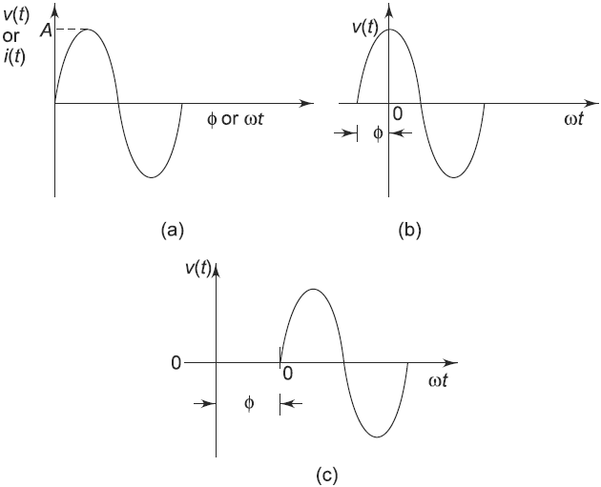

As the magnitude of the waveform is not constant, the waveform can be measured in different ways. These are instantaneous, peak, peak to peak, root mean square (rms) and average values.

**1.6.4 Instantaneous Value**

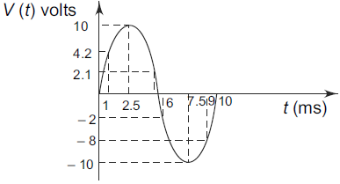

Consider the sine wave shown in above figure. At any given time, it has some instantaneous value. This value is different at different points along the waveform. In above figure during the positive cycle, the instantaneous values are positive and during the negative cycle, the instantaneous values are negative. In above figure shown at time 1 ms, the value is 4.2 V; the value is 10 V at 2.5 ms, – 2 V at 6 ms and – 10 V at 7.5 and so on.

**1.6.5 Peak Value**

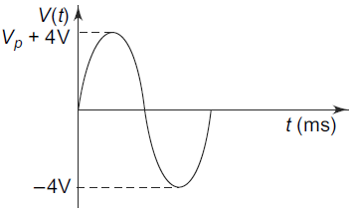

The peak value of the sine wave is the maximum value of the wave during positive half cycle, or maximum value of wave during negative half cycle. Since the value of these two are equal in magnitude, a sine wave is characterized by a single peak value. The peak value of the sine wave is shown in above figure; here the peak value of the sine wave is 4 V.

**1.6.6 Peak to Peak Value**

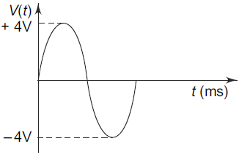

The peak to peak value of a sine wave is the value from the positive to the negative peak as shown in above figure. Here the peak to peak value is 8 V.

**1.6.7 Average Value**

In general, the average value of any function v(t), with period T is given by

$$v_{av}=\frac{1}{T}\int_{0}^{T}{v\left(t\right)dt}$$

That means that the average value of a curve in the X-Y plane is the total area under the complete curve divided by the distance of the curve. The average value of a sine wave over one complete cycle is always zero. So the average value of a sine wave is defined over a half-cycle, and not a full cycle period.

The average value of the sine wave is the total area under the half-cycle curve divided by the distance of the curve.

The average value of the sine wave *v(t) = VP sin ωt* is given by

$$v_{av}=\frac{1}{π}\int_{0}^{π}{V_{P}sin ωt d(ωt)}$$

$$v_{av}=\frac{1}{π}\left[-V_{P}\cos{ωt}\right]{π \atop 0}$$

$$v_{av}=\frac{2V_{P}}{π}=0.637V_{P}$$

The average value of a sine wave is shown by the dotted line in below figure.

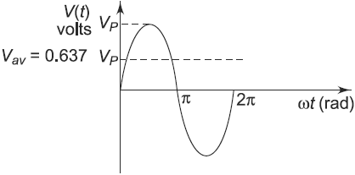

**1.6.8 Root Mean Square Value or Effective Value**

The root mean square (rms) value of a sine wave is a measure of the heating effect of the wave. When a resistor is connected across a dc voltage source as shown in Fig. 2.19(a), a certain amount of heat is produced in the resistor in a given time. A similar resistor is connected across an ac voltage source for the same time as shown in Fig. 2.19(b). The value of the ac voltage is adjusted such that the same amount of heat is produced in the resistor as in the case of the dc source. This value is called the rms value.

That means the rms value of a sine wave is equal to the dc voltage that produces the same heating effect. In general, the rms value of any function with period T has an effective value given by

$$V_{RMS}=\sqrt{\frac{1}{T}\int_{0}^{T}{{v\left(t\right)}^{2}}}dt$$

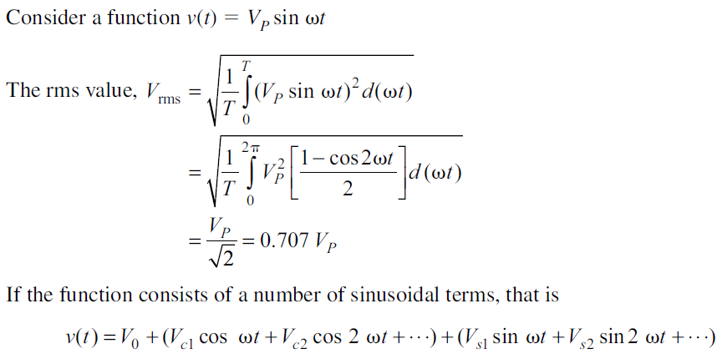

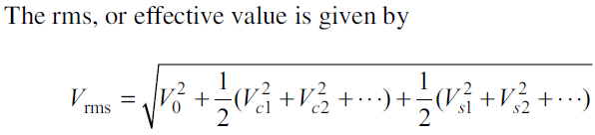

**1.6.9 Peak Factor**

The peak factor of any waveform is defined as the ratio of the peak value of the wave to the rms value of the wave.

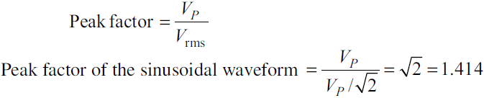

**1.6.10 Form Factor**

Form factor of a waveform is defined as the ratio of rms value to the average value of the wave.

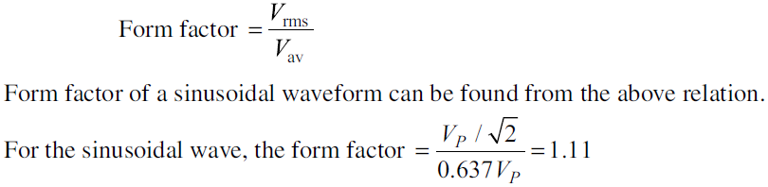

**1.7 PHASOR REPRESENTATION**

A phasor diagram can be used to represent a sine wave in terms of its magnitudeand angular position. Examples of phasor diagrams are shown in below figures.

In Fig. (a), the length of the arrow represents the magnitude of the sine wave; angle ϴ represents the angular position of the sine wave. In Fig. (b), the magnitude of the sine wave is one and the phase angle is 30°. In Fig. (c) and (d), the magnitudes are four and three, and phase angles are 135° and 225°, respectively. The position of a phasor at any instant can be expressed as a positive or negative angle. Positive angles are measured counterclockwise from 0°, whereas negative angles are measured clockwise from 0°. For a given positive angle ϴ, the corresponding negative angle is ϴ -360°. This is shown in Fig. (e). In Fig. (f), the positive angle 135° of vector A can be represented by a negative angle -225°, (135°-360°).

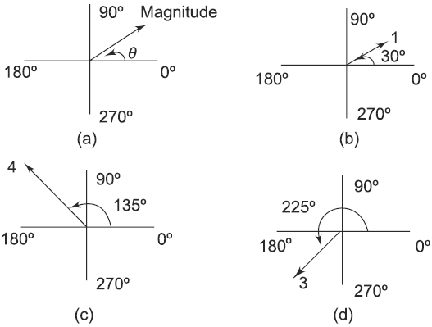

A phasor diagram can be used to represent the relation between two or more sine waves of the same frequency. For example, the sine waves shown in Fig. (g) can be represented by the phasor diagram shown in Fig. (h). In the Fig. (g) and Fig. (h), sine wave B lags behind sine wave A by 45°; sine wave C leads sine wave A by 30°. The length of the phasors can be used to represent

peak, rms, or average values.

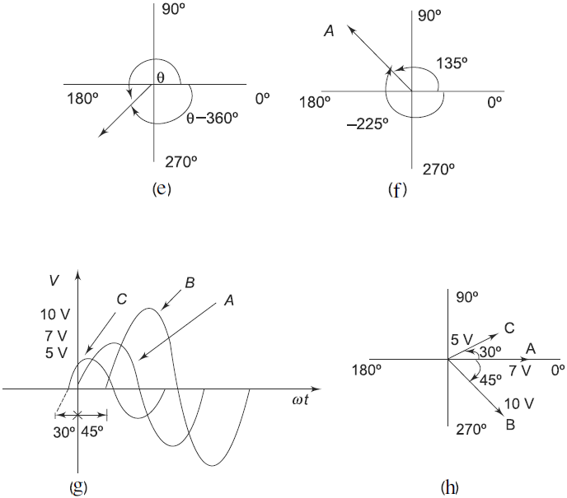

**1.8 POWER AC CIRCUITS**

**1.8.1 Instantaneous Power**

In a purely resistive circuit, all the energy delivered by the source is dissipated in the form of heat by the resistance. In a purely reactive(inductive or capacitive) circuit, all the energy delivered by the source is stored by the inductor or capacitor in its magnetic or electric field during a portion of the voltage cycle, and then is returned to the source during another portion of the cycle, so that no net energy is transferred. When there is complex impedance in a circuit, part of the energy is alternately stored and returned by the reactive part, and part of it is dissipated by the resistance. The amount of energy dissipated is determined by the relative values of resistance and reactance.

Consider a circuit having complex impedance. Let **v(t) = Vm cos ωt** be the voltage applied to the circuit and let **i(t) = Im cos (ωt + ϴ)** be the corresponding current flowing through the circuit. Then the power at any instant of time is

$$P\left(t\right)=v\left(t\right)i\left(t\right)=V_{m}\cos{ωt}I_{m}\cos\left(ωt+θ\right) (i)$$

$$P\left(t\right)=\frac{V_{m}I_{m}}{2}\left[\cos\left(2ωt+θ\right)+\cos{θ}\right] (ii)$$

Equation (ii) represents instantaneous power. It consists of two parts. One is a fixed part, and the other is time-varying which has a frequency twice that of the voltage or current waveforms. The voltage, current and power waveforms are shown in Figs a and b.

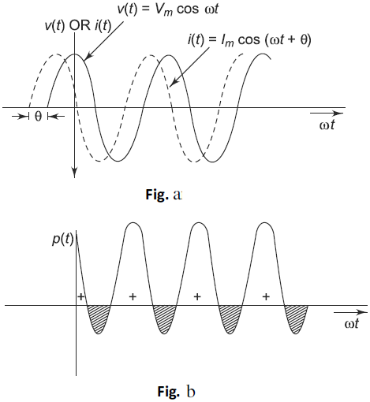

Here, the negative portion (hatched) of the power cycle represents the power returned to the source. Figure b shows that the instantaneous power is negative whenever the voltage and current are of opposite sign. In Fig. b, the positive portion of the power is greater than the negative portion of the power; hence the average power is always positive, which is almost equal to the constant part of the instantaneous power (Eq. ii). The positive portion of the power cycle varies with the phase angle between the voltage and current waveforms. If the circuit is pure resistive, the phase angle between voltage and current is zero; then there is no negative cycle in the P(t) curve. Hence, all the power delivered by the source is completely dissipated in the resistance.

If ϴ becomes zero in Eq. i, we get

$$P\left(t\right)=v\left(t\right)i\left(t\right)$$

$$=V_{m}I_{m}\cos^{2}{ωt}$$

$$=\frac{V_{m}I_{m}}{2}\left[1+\cos\left(2ωt\right)\right]$$

The waveform for Eq. 2.3, is shown in Fig. 2.87, where the power wave has a frequency twice that of the voltage or current. Here the average value of power is VmIm/2. When phase angle ϴ is increased, the negative portion of the power cycle increases and lesser power is dissipated. When ϴ becomes π/2, the positive and negative portions of the power cycle are equal. At this instant, the power dissipated in the circuit is zero, i.e. the power delivered to the load is returned to the source.

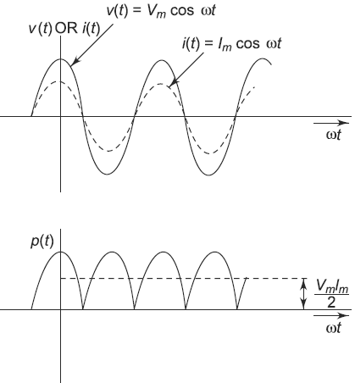

**1.8.2 Average Power**

To find the average value of any power function, we have to take a particular time interval from t1 to t2; by integrating the function from t1 to t2 and dividing the result by the time interval t2 – t1, we get the average power.

$$P=\frac{1}{t_{2}-t_{1}}\int_{t_{1}}^{t_{2}}{p\left(t\right)dt}$$

In general, the average value over one cycle is

$$P_{av}=\frac{1}{T}\int_{0}^{T}{p\left(t\right)dt}$$

By integrating the instantaneous power P(t) in above over one cycle, we get average power

$$P_{av}=\frac{1}{T}\int_{0}^{T}{\left\{\frac{V_{m}I_{m}}{2}\left[\cos\left(2ωt+θ\right)+\cos{θ}\right]\right\}dt}$$

$$P_{av}=\frac{1}{T}\int_{0}^{T}{\frac{V_{m}I_{m}}{2}\left[\cos\left(2ωt+θ\right)\right]dt+\frac{1}{T}\int_{0}^{T}{\frac{V_{m}I_{m}}{2}\cos{θ}dt}}$$

In Eq. 2.6, the first term becomes zero, and the second term remains. The average power is therefore

$$P_{av}=\frac{V_{m}I_{m}}{2}\cos{θ} W$$

We can write above equation as

$$P_{av}=\left(\frac{V_{m}}{\sqrt{2}}\right)\left(\frac{I_{m}}{\sqrt{2}}\right)\cos{θ}$$

In the above equation, $\left(\frac{V_{m}}{\sqrt{2}}\right)$ and $\left(\frac{I_{m}}{\sqrt{2}}\right)$ are the effective values of both voltage and current.

$$P_{av}=V_{eff}I_{eff}\cos{θ}$$

To get average power, we have to take the product of the effective values of both voltage and current multiplied by cosine of the phase angle between voltage and the current.

If we consider a purely resistive circuit, the phase angle between voltage and

current is zero. Hence, the average power is

$$P_{av}=\frac{1}{2}V_{m}I_{m}=\frac{1}{2}{I_{m}}^{2}R$$

If we consider a purely reactive circuit (i.e. purely capacitive or purely inductive), the phase angle between voltage and current is 90°. Hence, the average power is zero or Pav 5 0.

If the circuit contains complex impedance, the average power is the power dissipated in the resistive part only.

**1.8.3 Apparent Power, Power Factor and Significance**

The power factor is useful in determining useful power (true power) transferred to a load. The highest power factor is 1, which indicates that the current to a load is in phase with the voltage across it (i.e. in the case of resistive load). When the power factor is 0, the current to a load is 90° out of phase with the voltage (i.e. in case of reactive load).

Consider the following equation

$$P_{av}=\frac{V_{m}I_{m}}{2}\cos{θ} W$$

In terms of effective values

$$P_{av}=\left(\frac{V_{m}}{\sqrt{2}}\right)\left(\frac{I_{m}}{\sqrt{2}}\right)\cos{θ}$$

$P_{av}=V_{eff}I_{eff}\cos{θ}$ W

The average power is expressed in watts. It means the useful power transferred from the source to the load, which is also called true power. If we consider a dc source applied to the network, true power is given by the product of the voltage and the current. In case of sinusoidal voltage applied to the circuit, the product of voltage and current is not the true power or average power. This product is called apparent power. The apparent power is expressed in volt amperes, or simply VA.

$$Apparent Power=V_{eff}I_{eff}$$

The average power depends on the value of $\cos{θ}$; this is called the power factor of the circuit.

$$Power Factor \left(PF\right)=\cos{θ}=\frac{P_{av}}{V_{eff}I_{eff}}$$

Therefore, power factor is defined as the ratio of average power to the apparent power, whereas apparent power is the product of the effective values of the current and the voltage. Power factor is also defined as the factor with which the volt amperes are to be multiplied to get true power in the circuit.

In the case of sinusoidal sources, the power factor is the cosine of the phase angle between voltage and current

$$Power Factor \left(PF\right)=\cos{θ}$$

As the phase angle between voltage and total current increases, the power factor decreases. The smaller the power factor, the smaller the power dissipation. The power factor varies from 0 to 1. For purely resistive circuits, the phase angle between voltage and current is zero, and hence the power factor is unity. For purely reactive circuits, the phase angle between voltage and current is 90°, and hence the power factor is zero. In an RC circuit, the power factor is referred to as leading power factor because the current leads the voltage. In an RL circuit, the power factor is referred to as lagging power factor because the current lags behind the voltage.

**1.8.4 Real and Reactive Power**

We know that the average power dissipated is $P_{av}=V_{eff}I_{eff}\cos{θ}$

From the impedance triangle shown in below figure.

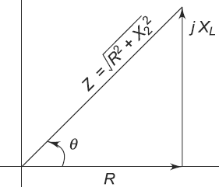

$$\cos{θ}=\frac{R}{\left|Z\right|}$$

$$V_{eff}=I_{eff} Z$$

If we substitute these Eqs in $P_{av}$ Eq., we get

$$P_{av}=\left[I_{eff} Z\right]I_{eff}\left[\frac{R}{\left|Z\right|}\right]$$

$P_{av}={I_{eff}}^{2}R$ watts

This gives the average power dissipated in a resistive circuit.

If we consider a circuit consisting of a pure inductor, the power in the inductor

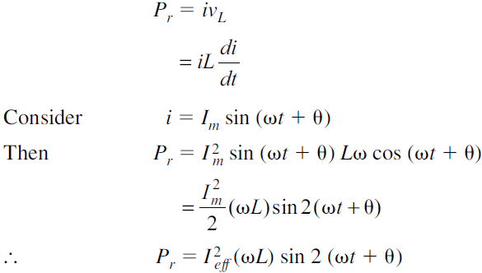

From the above equation, we can say that the average power delivered to the circuit is zero. This is called reactive power. It is expressed in volt-amperes reactive (VAR).



But From impedance triangle, we have



Substituting XL value in Pr Eq., we get

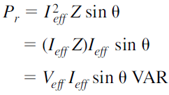

**1.8.5 Complex Power**

A generalized impedance phase diagram is shown in Fig. a. A phasor relation for power can also be represented by a similar diagram because of the fact that true power Pav and reactive power Pr differ from R and X by a factor ${I_{eff}}^{2}$, as shown in Fig. a.

The resultant power phasor ${I_{eff}}^{2}Z$, represents the apparent power Pa. At any instant in time, Pa is the total power that appears to be transferred between the source and reactive circuit. Part of the apparent power is true power and part of it is reactive power. Absolute value of complex power is called apparent power.

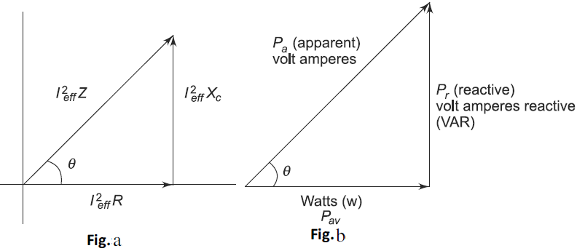



The power triangle is shown in Fig. b.

From Fig. a, we can write

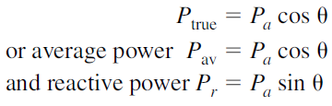

**1.9 ANALYSIS OF SINGLE PHASE AC SERIES CIRCUITS**

The impedance diagram is a useful tool for analyzing series ac circuits. Basically we can divide the series circuits as RL, RC and RLC circuits. In the analysis of series ac circuits, one must draw the impedance diagram. Although the impedance diagram usually is not drawn to scale, it does represent a clear picture of the phase relationships.

**1.9.1 RL series circuit**

If we apply a sinusoidal input to an RL circuit, the current in the circuit and all voltages across the elements are sinusoidal. In the analysis of the RL series circuit, we can find the impedance, current, phase angle and voltage drops. In Fig. (a) the resistor voltage (VR) and current (I ) are in phase with each other, but lag behind the source voltage (VS). The inductor voltage (VL) leads the source voltage (VS). The phase angle between current and voltage in a pure inductor is always 90°. The amplitudes of voltages and currents in the circuit are completely dependent on the values of elements (i.e. the resistance and inductive reactance). In the circuit shown, the phase angle is somewhere between zero and 90° because of the series combination of resistance with inductive reactance, which depends on the relative values of R and XL.

The phase relation between current and voltages in a series RL circuit is shown in Fig. (b). Here VR and I are in phase. The amplitudes are arbitrarily chosen. From Kirchhoff’s voltage law, the sum of the voltage drops must equal the applied voltage. Therefore, the source voltage VS is the phasor sum of VR and VL.

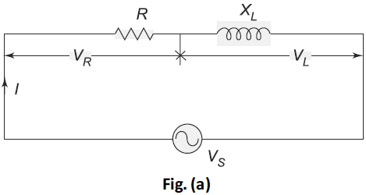



The phase angle between resistor voltage and source voltage is



Where ϴ is also the phase angle between the source voltage and the current. The phasor diagram for the series RL circuit that represents the waveforms in Fig. (c).

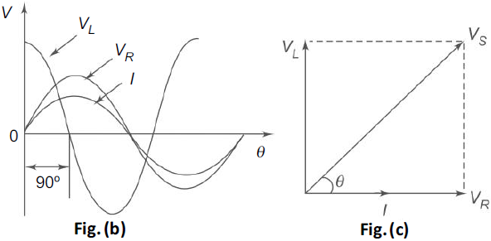

**1.9.2 RC series circuit**

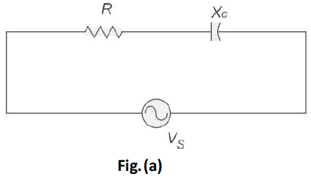

When a sinusoidal voltage is applied to an RC series circuit, the current in the circuit and voltages across each of the elements are sinusoidal. The series RC circuit is shown in Fig. (a). Here the resistor voltage and current are in phase with each other. The capacitor voltage lags behind the source voltage. The phase angle between the current and the capacitor voltage is always 90°. The amplitudes and the phase relations between the voltages and current depend on the ohmic values of the resistance and the capacitive reactance. The circuit is a series combination of both resistance and capacitance; and the phase angle between the applied voltage and the total current is somewhere between zero and 90°, depending on the relative values of the resistance and reactance. In a series RC circuit, the current is the same through the resistor and the capacitor. Thus, the resistor voltage is in phase with the current, and the capacitor voltage lags behind the current by 90° as shown in Fig. (b).

Here, I leads VC by 90°. VR and I are in phase. From Kirchhoff’s voltage law, the sum of the voltage drops must be equal to the applied voltage. Therefore, the source voltage is given by



The phase angle between the resistor voltage and the source voltage is



Since the resistor voltage and the current are in phase, ϴ also represents the phase angle between the source voltage and current. The voltage phasor diagram for the series RC circuit, voltage and current phasor diagrams represented by the waveforms in Fig.(b) are shown in Fig. (c).

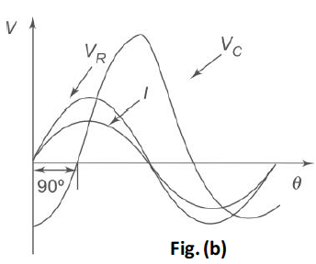

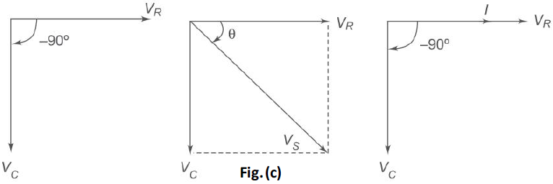

**1.9.3 RLC series circuit**

A series RLC circuit is the series combination of resistance, inductance and capacitance. If we observe the impedance diagrams of series RL and series RC circuits as shown in Fig. (a) and (b), the inductive reactance, XL , is displayed on the + j axis and the capacitive reactance, XC , is displayed on the – j axis. These reactance are 180° apart and tend to cancel each other.

The magnitude and type of reactance in a series RLC circuit is the difference of the two reactance. The impedance for an RLC series circuit is given by



Similarly, the phase angle for an RLC circuit is

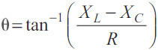

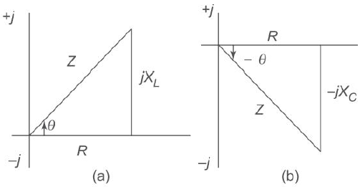

**1.10 SERIES RESONANCE**

In many electrical circuits, resonance is a very important phenomenon. The study of resonance is very useful, particularly in the area of communications. For example, the ability of a radio receiver to select a certain frequency, transmitted by a station and to eliminate frequencies from other stations is based on the principle of resonance. In a series RLC circuit, the current lags behind, or leads the applied voltage depending upon the values of XL and XC.XL causes the total current to lag behind the applied voltage, while XC causes the total current to lead the applied voltage. When XL > XC, the circuit is predominantly inductive, and when XC > XL the circuit is predominantly capacitive. However, if one of the parameters of the series RLC circuit is varied in such a way that the current in the circuit is in phase with the applied voltage, then the circuit is said to be in resonance.

Consider the series RLC circuit shown in below Figure.

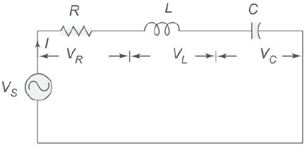

The total impedance for the series RLC circuit is

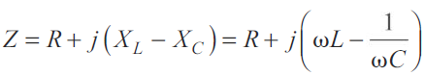

It is clear from the circuit that the current I = VS/Z

The circuit is said to be in resonance if the current is in phase with the applied voltage. In a series RLC circuit, series resonance occurs when XL = XC. The frequency at which the resonance occurs is called the resonant frequency.

Since XL = XC, the impedance in a series RLC circuit is purely resistive. At the resonant frequency*, fr*, the voltages across capacitance and inductance are equal in magnitude. Since they are 180o out of phase with each other, they cancel each other and, hence zero voltage appears across the LC combination.

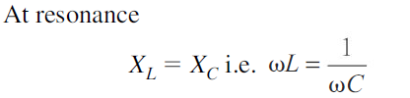

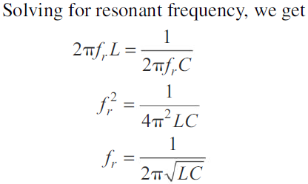

In a series RLC circuit, resonance may be produced by varying the frequency, keeping L and C constant; otherwise, resonance may be produced by varying either L or C for a fixed frequency.

**1.11 BANDWIDTH OF AN RLC CIRCUIT**

The bandwidth of any system is the range of frequencies for which the current or output voltage is equal to 70.7% of its value at the resonant frequency, and it is denoted by BW. Below Figure shows the response of a series RLC circuit.

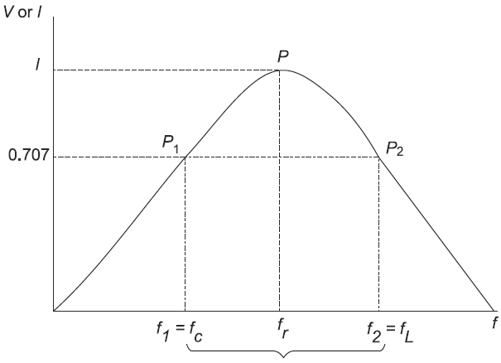

Here the frequency f1 is the frequency at which the current is 0.707 times the current at resonant value, and it is called the lower cut-off frequency. The frequency f2 is the frequency at which the current is 0.707 times the current at resonant value (i.e. maximum value), and is called the upper cutoff frequency. The bandwidth, or BW, is defined as the frequency difference between f2 and f1.



The unit of BW is hertz (Hz). If the current at P1 is 0.707 Imax, the impedance of the circuit at this point is $\sqrt{2}R$, and hence

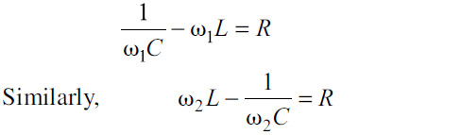

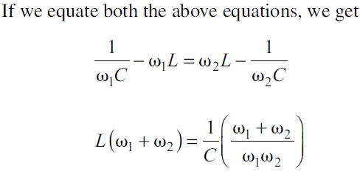

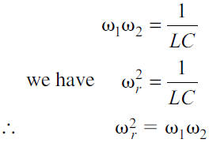

If we add first two Equations, we get

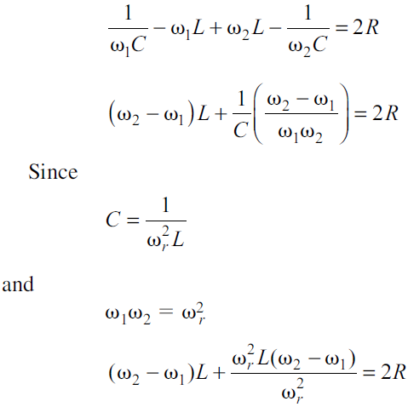

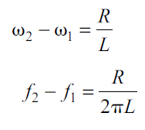

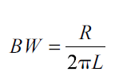

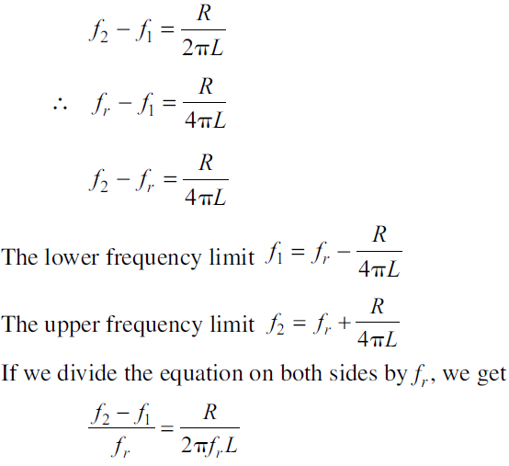

Here an important property of a coil is defined. It is the ratio of the reactance of the coil to its resistance. This ratio is defined as the Q of the coil. Q is known as a figure of merit, it is also called quality factor and is an indication of the quality of a coil.

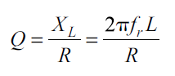

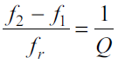

The upper and lower cut-off frequencies are sometimes called the half-power frequencies. At these frequencies the power from the source is half of the power delivered at the resonant frequency.

At resonant frequency, the power is

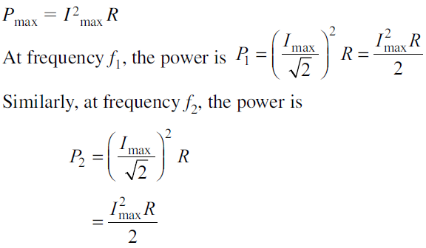

The response curve in shown in above Figure is also called the selectivity curve of the circuit. Selectivity indicates how well a resonant circuit responds to a certain frequency and eliminates all other frequencies. The narrower the bandwidth, the greater the selectivity.